FAQs about PNC Bank and its account for International Students

Q: Who is PNC Bank?
- PNC Bank is the 6th largest bank in the U.S. PNC has 2,600 branches and 9,000 ATMs in 19 States and the District of Columbia.
- PNC is located in the orange colored States on this map.
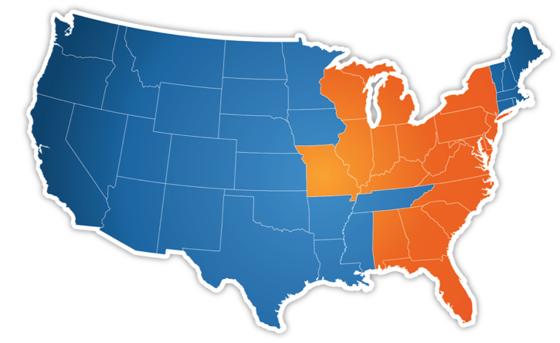

Q: What is PNC web site address?
- The main website is www.pnc.com
- You can learn more about PNC Bank’s student banking products at www.pnc.com/studentbanking.

Q: What product or service does PNC Bank offer to students?
- PNC Bank’s primary product for students is a checking account called Virtual Wallet – Student®.
- In addition to the Virtual Wallet – Student account, PNC Bank offers a full range of banking services such as safe deposit boxes and wire transfer services.

Q: What are the key features of Virtual Wallet – Student?
- There is no minimum balance requirement and no monthly maintenance fee for 6 years¹
- Free Mobile Banking, Mobile Deposit, Online Banking and Bill Pay²
- Unlimited use of PNC ATMs.
- One overdraft fee refund on first incident within the first 12 months of account opening³
- One free wire transfer per monthly statement period⁴
- Reimbursed for up to 2 non-PNC ATM transaction fees each statement cycle⁵
- Enroll in email or text alerts: notifications for things such as when a direct deposit enters your account, when a balance falls below or above a specified limit, or when an account overdraws
- In the event of an overdraft, available funds can be transferred automatically from the primary overdraft protecting account to cover the overage
- Savings Engine® — Option to set aside a specific amount to save on a regular basis

Q: Where can I open a Virtual Wallet Account?
- You can visit any PNC branch or visit the PNC table during New Student Orientation Day on campus. Branch locations can be found by visiting pnc.com and using the branch locator tool.

Q: What do I need to open an account?
- You’ll need your passport and your Student ID card.

Footnotes / Disclosure
1: Proof of active enrollment in an educational institution is required to receive a monthly service charge waiver. This waiver will expire 6 years after it is assigned to your account.

2: A supported mobile device is needed to use Mobile Banking. Standard message and data rates may apply. PNC does not charge a fee for Mobile Banking. However, third party message and data rates may apply. These include fees your wireless carrier may charge you for data usage and text messaging services. Check with your wireless carrier for details regarding your specific wireless plan and any data usage or text messaging charges that may apply. Also, a supported mobile device is needed to use the Mobile Banking App. Mobile Deposit is a feature of PNC Mobile Banking. Use of the Mobile Deposit feature requires a supported camera-equipped device and you must download a PNC mobile banking app. Eligible PNC Bank account and PNC Bank Online Banking required. Certain other restrictions apply. See the mobile banking terms and conditions in the PNC Online Banking Service Agreement.

3: Although the fee may be refunded, the transaction will be considered an overdraft or nonsufficient funds (NSF) occurrence when determining any subsequent overdraft or NSF fee.

4: Customers in the Student Banking program who are enrolled at a designated PNC Alliance or Access school will receive 1 free domestic or international incoming wire per statement period. Otherwise, a $15 incoming wire fee will apply to all incoming wires. If you don’t see your school at pnc.com/student banking, please call 1-877-PNC-1000 or stop by any PNC Bank.

5: The fee for the first two domestic or international non-PNC Bank ATM transactions made on your Spend, Reserve or Growth accounts during the statement period will be reimbursed to your Spend account at the end of the statement period. Fees in excess of two per statement period will not be reimbursed.

